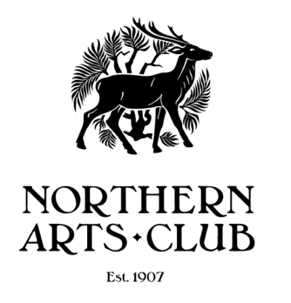
8 Bon Accord Square Aberdeen AB11 6DJ
Telephone: 01224 586928
www.northernartsclub.co.uk

Membership Form 2021 - 2022

Welcome to the Northern Arts Club. We are delighted that you have decided to join us/renew your membership subscription and we look forward to welcoming you during the year.

Please complete this form which is your subscription for the year. It also allows us to store your membership details in compliance with the General Data Protection Regulations 2018, which relate to the safe storage of members’ personal information. (NB This information is used only for internal club purposes and will not be passed to external third parties without your express permission).

Annual membership includes reductions for classes and workshops run by the Northern Arts Club. The current fee for “drop-in” art sessions is £3.00; Fees for additional classes will be circulated as and when.

Treasurer

Subscription Fee 1st September 2021 to 31st August 2022 - £20 [mark X for method of payment]

Cheque [Payable to Northern Arts Club] Enclosed:
Bank Transfer – Bank of Scotland  Sort code: 80-12-08 Account number: 00420253 | Reference: own name

I consent to the following being stored as described above [please print clearly]
Forename: | Address:
Surname:
Contact number: | Post Code:
Email:

How did you hear about the club? (Please circle)
Website - facebook - Gazette - Westhill Bulletin - MBC Magazine - Local Newspaper - Recommendation - Poster Display - Other

For Office Use: mark X when completed
Fees Collected | X | Membership Secretary |  | Database Updated

