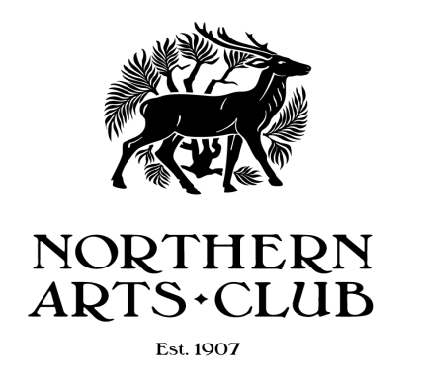
8 Bon Accord Square Aberdeen AB11 6DJ
Telephone: 01224 586928

Club Rules

General Information

- No alcohol may be brought into the building without the prior consent of the Northern Arts Club Council.
- No animals with the exception of care or guide dogs are permitted in the building.
- Please note that the building does not have a TV licence and thus no TV programmes may be watched either live or via the internet.
- No photographs may be taken of any artwork in the building without the prior written consent of the Northern Arts Club Council.

Health and Safety Policy

- The maximum occupancy for the building is 49 persons per floor. This is in line with the Fire Risk Assessments.
- All Members must ensure that they are familiar with the Northern Arts Club Emergency Procedures document.
- The Session Leaders referred to in the Emergency Procedures document are the Director of any Bridge session in progress, a nominated Art Member or the hirer of the room or their deputy on the day. Where a group makes multiple room hire bookings, the Group Leader on the day is the nominated Session Leader.
- All Members must be familiar with the Emergency exits, location of Fire Extinguishers and First Aid Box.
- In an emergency, when leaving the First Floor room, press the black button in centre of green box adjacent to the door to disable the electronic lock.
- Any electrical items that are brought into the Northern Arts Club must be PAT tested on an annual basis. Any items that are not PAT tested may not be used within the club.
- Smoking is not permitted anywhere within the building or grounds including the front steps. For the avoidance of doubt the use of E-cigarettes is included in the above ban.
- All Contractors must provide a safe system of Work Permits where applicable.

Member’s Responsibility

- Ensure that all visitors that they bring into the club are aware of the Emergency Evacuation plans and procedures.
- Be responsible for the behaviour of those visitors at all times.
- Not bring on to the premises anything that may endanger other users or invalidate the club’s insurance policies e.g. flammable or explosive substances. This also includes all open flames items such as candles, oil lamps etc.
- Agree with the Northern Arts Club Council any decoration of the building before carrying out the decoration.
- Not permit any advertising material to be displayed or distributed on the premises unless authorised in writing in advance by the Northern Arts Council.
- Ensure that the premises are left clean and tidy.
- Ensure that all exits, landings and stairways are kept clear at all times.
- Ensure that no items obstruct the dumb waiter at any times.
- Ensure that any visitors to their sessions use the appropriate buzzer at the appropriate time on the intercom to access the building so as not to disturb other users.
- If the PC is used to either score a bridge session or to update key fob access, the PC must be backed up at the end of the session. The USB stick is kept in the safe and must be returned there after the back-up is complete.

Membership

Membership fees are payable on 1 September annually. The rate will be determined by the Northern Arts Club Council. The Scottish Bridge Union fee for Home Members will also be collected at the current rate if applicable. Membership reminders will be sent out in advance of 1 September and membership will lapse if no subscription has been paid by 30 September in the year that it is due. New members who join from 1 March to 31 August will pay a reduced rate of subscription as determined by the Northern Arts Club Council.

Personal Items

Any items or property left in the building is at the Member’s own risk. The Northern Arts Club accepts no liability for loss or damage.

Room Hire

Members may hire rooms within the building on a commercial basis and will be subjected to the same terms and conditions as Third Party hirers.

Security

Entry to the building is via a key fob system. All Members may have a key fob for their personal use and a deposit of £20.00 per key fob will be required. The deposit will be returned when the key fob is returned to the Northern Arts Club. The ley fob may not be given to a non-member of the Club.

Use of the Building

- All Members and their Guests must sign in on arrival and sign out on departure using the visitor’s book located in the front hall. (It is not acceptable to fill in the expected departure time on arrival).
- All Members must check that all windows and exit doors are securely closed and locked at the end of each session.
- Any crockery that is used during the session should be returned to the Basement Floor Kitchen and left on the work surface where indicated. Any rubbish - teabags etc. must be put into the grey bin in the kitchen and no items should be put in the dishwasher. (The dishwasher will be emptied and filled by the Cleaners).
- Any incidents e.g. Emergency Lighting coming on, Fire Extinguisher being used must be reported to the Northern Arts Club Treasurer as soon as possible.
- All incidents that require the use of the First Aid Box must be logged in the First Aid Book and the incident reported to the Club Treasurer as soon as possible.

Contingency plans

In the event that the building is rendered unusable by fire, flood etc. it is assumed that the safe currently located on the first floor would survive the incident and thus any important information must be kept there. Any member of the Club who keeps Club Equipment out of the building, should take precautions to ensure that such equipment can be recovered in the event of a fire, flood etc.

Should the building be unusable for a lengthy period of time, the Northern Arts Club Council would endeavour to rent alternative premises for the duration of the closure. It is recognised that this may have an irrevocable impact on current room hire arrangements.

April 2016

